**Project Report Format**

1. **INTRODUCTION**

1.1 Project Overview

**It is essential to maintain proper levels of gas, as it is used in operating theatres in order to improve patient’s condition. Oxygen is the most common and important gas that has to be checked at regular intervals for availability. Leakage of these gases can pose a severe threat to the safety of lives in hospitals. Through this smart system, staff will now be able to check the level of gas present for use and will be able to take safety measures when alerted during a gas leak. Sensors are used to record the levels of gases, which are stored in the cloud. These values are displayed on a mobile application for the users.**

**TECHNICAL ARCHITECTURE**

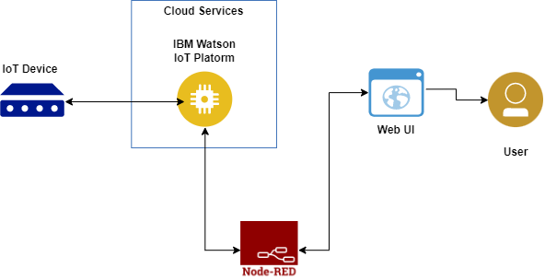

1.2 Purpose

The Medical Gas Pipeline System is a key element of every hospital. The MGPS provides vital medical gases for patient ventilation and various clinical applications.

2. **IDEATION & PROPOSED SOLUTION**

2.1 Problem Statement Definition

MOXA IoT case study - This system integrator focuses on providing centralized **gas pipeline monitoring systems** for **hospitals**. The service they provide makes ...

You've visited this page many times. Last visit: 19/5/23

2.2 Empathy Map Canvas

Through this smart **system**, staff will now be able to check the level of **gas** present for use and will be able to take safety measures when alerted during a **gas** ...

2.3 Ideation & Brainstorming

This system integrator focuses on providing centralized **gas pipeline monitoring systems for hospitals**. The service they provide makes it possible for ...

2.4 Proposed Solution

This system integrator focuses on providing centralized **gas pipeline monitoring systems for hospitals**. The service they provide makes it possible for ..

3. **REQUIREMENT ANALYSIS**

3.1 Functional requirement

3.2 Non-Functional requirements

**4. PROJECT DESIGN**

4.1 Data Flow Diagrams

4.2 Solution & Technical Architecture

4.3 User Stories

**5. CODING & SOLUTIONING (Explain the features added in the project along with code)**

5.1 Feature 1

5.2 Feature 2

5.3 Database Schema (if Applicable)

**6. RESULTS**

.1 Performance 6Metrics

This paper develops and discusses a classification of conditions such as flow regime and **gas** composition. .

**7. ADVANTAGES & DISADVANTAGES**

* They are ideally suited to transport the liquids and gases.
* Pipelines can be laid through difficult terrains as well as under water.
* It involves very low energy consumption.
* It needs very little maintenance.

**8. CONCLUSION**

**Patient safety** is of paramount importance in the design, installation, commissioning, and operation of medical gas pipeline systems (MGPS)

**9. FUTURE SCOPE**

The **device provides an audible feedback to alert technician and their staff when the pressure ranges becomes unstable**.

**10. APPENDIX**

This system integrator focuses on providing centralized **gas pipeline monitoring systems for hospitals**. The service they provide makes it possible for ...